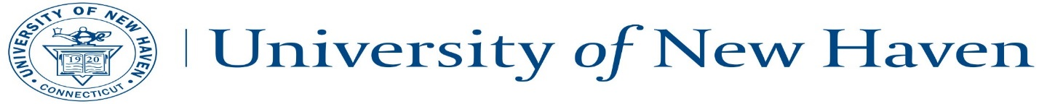
Faculty Process for Internships - Charger Link

- Students begin the internship documentation process by completing the form in Charger Link (see student instructions for details)

- Once students submit the form, the three-part approval routing process begins automatically, as follows:
1. Form reviewed by Career Development Center (CDC) to ensure proper documentation and consistency in reporting fields; CDC begins approval routing process.
2. Email sent to student internship supervisor at company to verify the internship. Employer approves or declines internship via an email link.
3. Upon employer approval, email is sent to assigned Faculty Advisor to review internship and to approve or deny internship via email link.

Faculty can approve internships without logging in to the system – just click the link in the email. Login provides additional resources, noted below:

- Faculty login to Charger Link via http://unh.acade-me.com , click on Faculty button on bottom left:
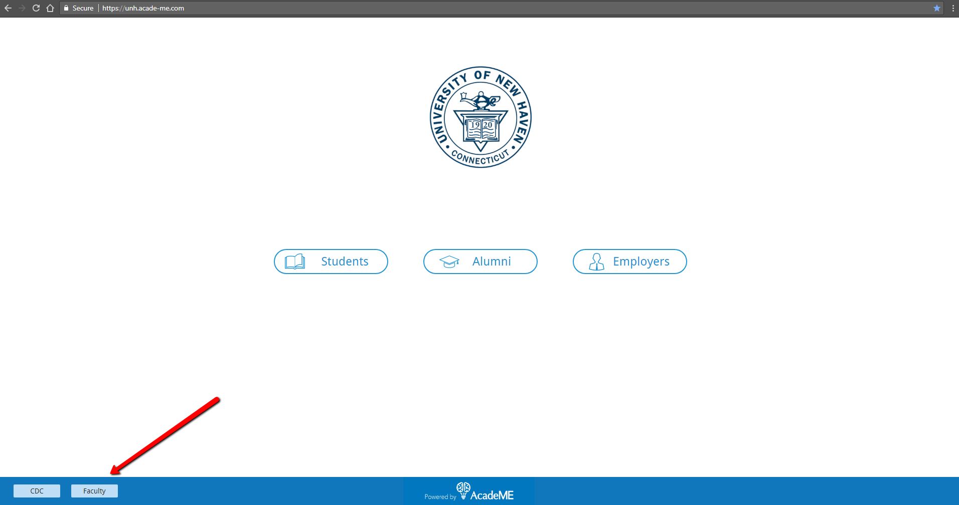

- Login using your UNH email and the temp password assigned to you (first part of email + 123) so jdoe@newhaven.edu will have a temp password of jdoe123
You can immediately change your password after login
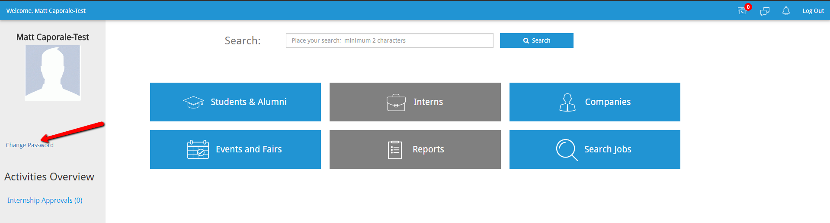

- Once you login, this is your dashboard. You have a few sections with limited access to CDC databases such as Students/Alumni and Companies, as well as full access to viewing jobs and career events in the system.
Students/Alumni: You can look up a student by name and see their internship records, as well as their career profile (Click the icon by their name)
Companies: Search by company name to see if they are in our database. You can see their jobs and any events they attended.
Search Jobs: Search jobs by title, type, or keyword.
Events/Fairs: shows you previous and upcoming career events from the CDC

- To manage your interns, you will click on the gray Interns tab. You will also see a prompt on the left if you have any internships awaiting your approval

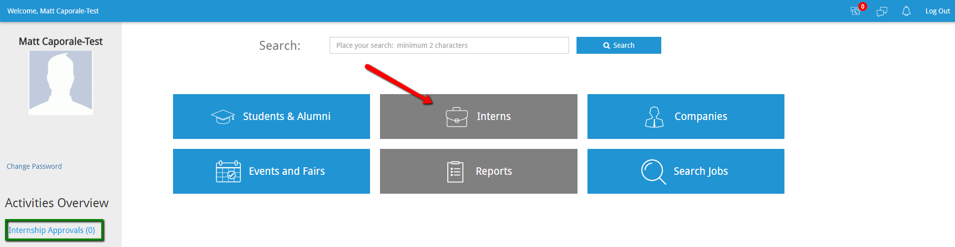
- You will then enter the Internship Dashboard where you will see your interns and have actions to manage your internships from your assigned major/program:
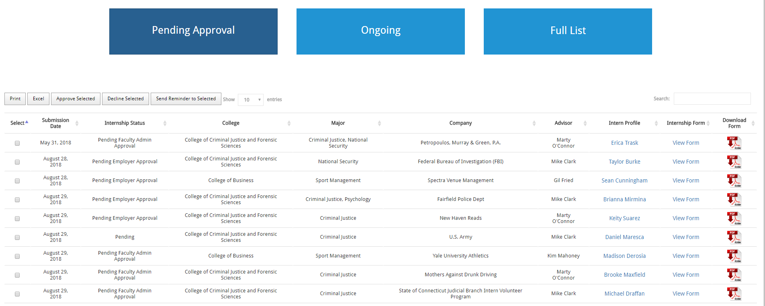

Pending Approval: All internships that are in the approval process appear under this tab. The ‘Internship Status’ field shows you where in the process the internship stands (Pending = awaiting CDC review; Pending Employer Approval; or Pending Faculty Approval)
Ongoing: All internships that have received final approval from faculty move to the ongoing tab where students will post their reflection logs (see #X below)

Full list: Complete list of all internships including Pending, Ongoing, and Completed

- When it is your turn to approve internships, you will receive an email from the system alerting you. You can approve/decline right from that email or choose to log into the system to manage the process.
- After you approve the internship, the form can be downloaded as a PDF and sent to the Registrar as documentation for registration)
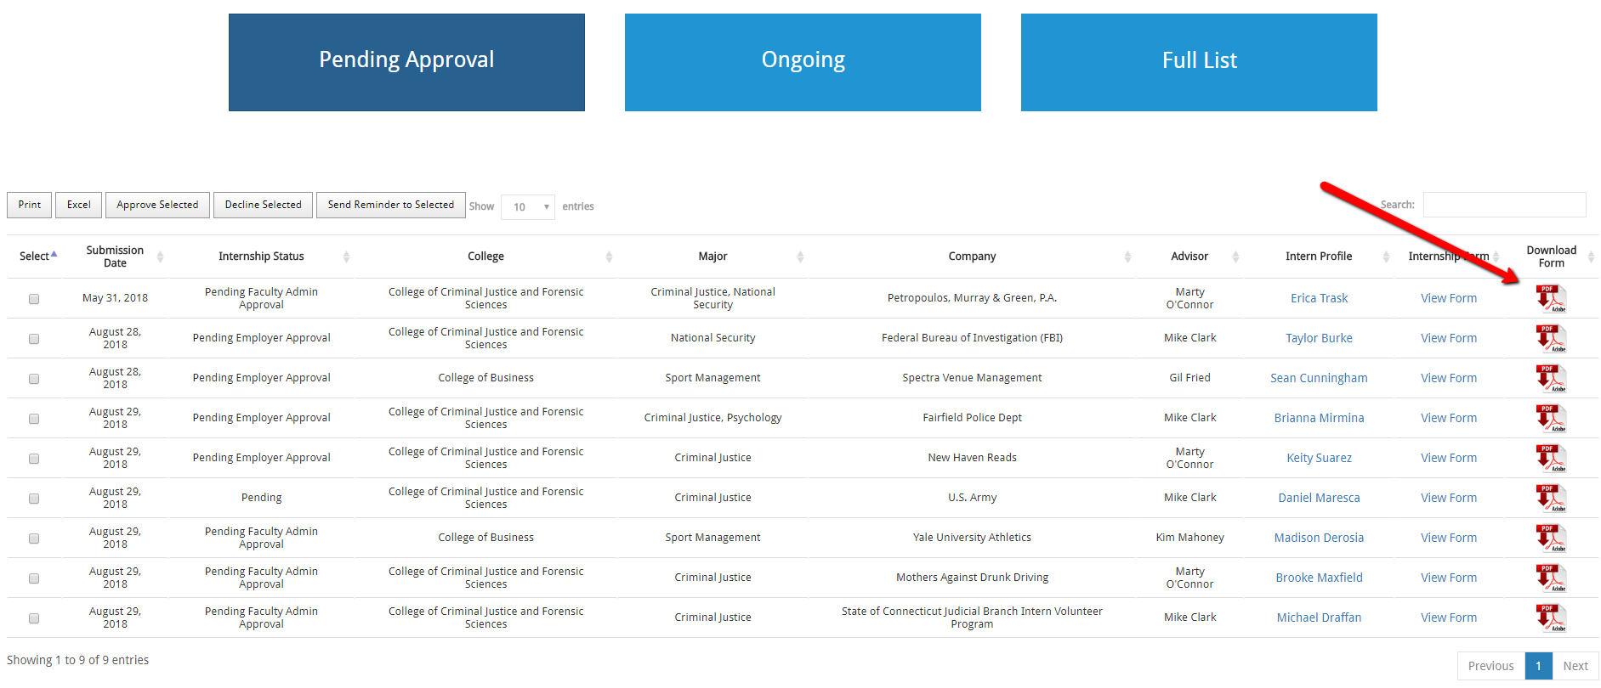

- If utilizing the system for written reflection assignments, click on ‘Ongoing” button from the main dashboard
You will then see your list of ongoing internships with a link to their ‘Evaluating Form’
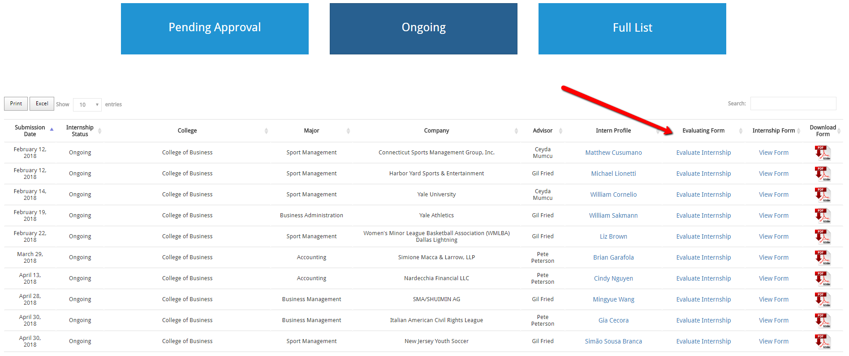
- Review student writing assignments and respond directly to them. Students will also track their work hours here. See student instructions for details on how this works from the student side.
We are in the process of creating a weekly reminder to students and faculty if they have written reports to submit/submitted for review.

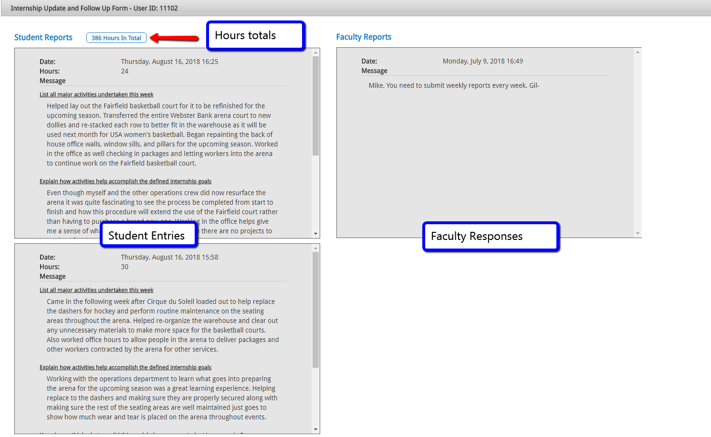

- When a student has completed their internship, the system alerts you via the Notifications icon in the top right corner.
Grading is done through the normal course grading process
- To run reports on your internships, select the Reports tab from your main dashboard screen
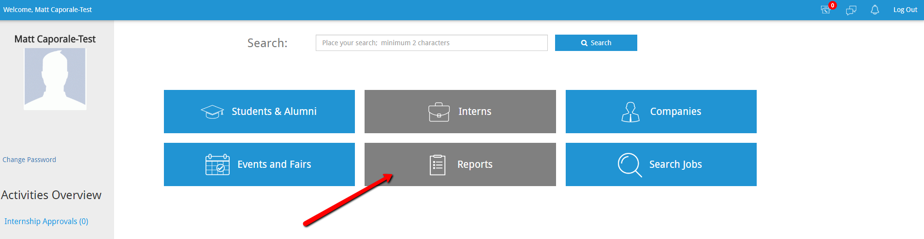

- Click on the Internship tab to open the reporting parameters, and then select ‘Internship Reports’ under the Query box.
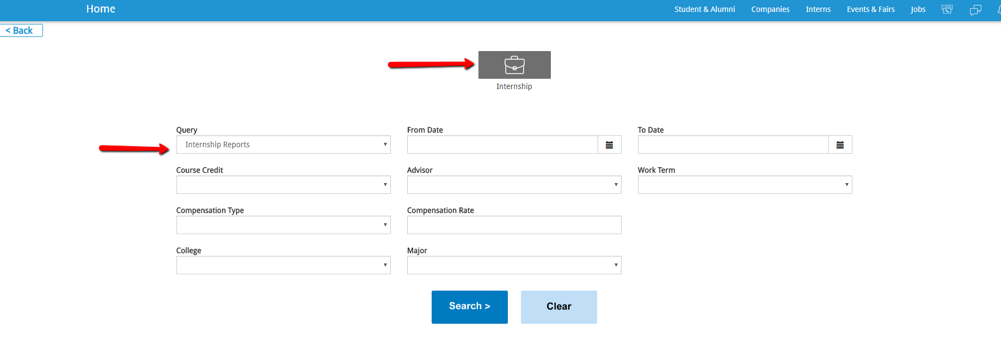

- You can run reports by Work Term, dates, major, advisor, course credits, college, etc. These reports are downloaded to Excel.
Additional reporting features will improve over time, with your feedback

- Technical support is available through the Career Development Center at all stages of the process.

